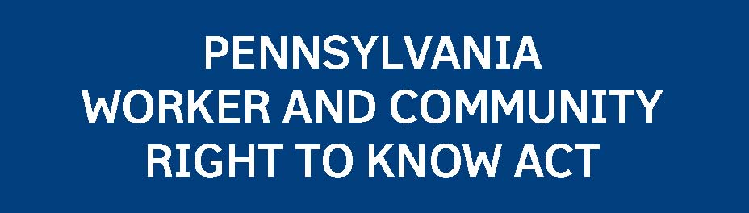
EMPLOYEE WORKPLACE NOTICE
The Environmental Hazard Survey Form (EHSF) provides information about any environmental hazards emitted, discharged or disposed of from the workplace. All employers are required to complete an EHSF when and if requested to do so by the Department of Labor & Industry. If an EHSF has been completed by a public sector employer or a private sector employer not covered by the OSHA Hazard Communication Standard, a copy must be provided to any employee upon request.
All containers and ports of pipelines of hazardous and non-hazardous substances in public sector workplaces and private sector workplaces not covered by the OSHA Hazard Communication Standard must be properly labeled. Employers must ensure that each label, sign, placard or other
operating instruction is prominently affixed and displayed on the container
If a public sector employee or an employee of a private sector workplace not covered by the OSHA Hazard Communication Standard believes that he or she has been discharged, disciplined or discriminated against by an employer for exercising his or her rights granted under the Pennsylvania Worker and Community Right to Know Act, that employee has 180 days
working days from the date the request is made, the employer fails to furnish the employee with an MSDS in the employer’s possession or fails to provide the employee with proof of the employer’s effort to obtain the requested MSDS from the manufacturer, importer, supplier or distributor and from the Department of Labor & Industry, the requesting employee may refuse to work with the substance.
PUBLIC SECTOR

The Pennsylvania Worker and Community Right to Know Act requires that information about hazardous substances in the workplace and in the environment is available to public sector employees and employees of private sector workplaces not covered by the Federal Occupational Safety and Health Administration (OSHA) Hazard Communication Standard and to all persons living or working in the state. Employee rights listed below are further defined in the Worker and Community Right to Know Act (P.L. 734, No. 159) and Regulations. For additional information, contact the Department of Labor & Industry, Bureau of PENNSAFE, 651 Boas Street, Room 155-E, Harrisburg, Pennsylvania 17121-0750; 717.783.2071;
FAX 717.783.5099; E-mail: li-pennsafe@state.pa.us.
Employee Workplace Notice:
Public sector employers (including state and local government agencies and public schools and public universities) and private sector employers not covered by the OSHA Hazard Communication Standard must post this notice informing employees of their rights under the law. This notice must be posted prominently in the workplace at a location where employee notices are normally posted.
Training:
Public sector employers and private sector employers not covered by OSHA Hazard Communication Standard must provide an annual education and training program to employees exposed to hazardous substances. The training program may be presented either in written form or in training sessions.
Hazardous Substance Survey Form:
The Hazardous Substance Survey Form (HSSF) provides an inventory of the hazardous substances found in the workplace during the prior calendar year. All employers must complete a workplace HSSF annually. Public sector employers and private sector employers not covered by OSHA must post the HSSF prominently in the workplace and must provide a copy to any employee upon request.
Work Area List:
The WorkArea List names the hazardous substances used or produced in
a specific work area in the workplace. Public sector employers and private
sector employers not covered by the OSHA Hazard Communication Standard must update a Work Area List at least annually, must provide a copy to any employee of the work area upon request, and must offer a copy to any employee newly assigned to that work area.
Material Safety Data Sheet:
The Material Safety Data Sheet (MSDS) provides detailed information about a hazardous substance. In public sector workplaces and private sector workplaces not covered by the OSHA Hazard Communication Standard, an MSDS must be accessible in the work area where the hazardous substance it describes is used. MSDSs must be readily available to employees without the intervention or permission of management or supervisors, and any employee may obtain and examine an MSDS for any hazardous substance in the workplace. If an employee’s request to
obtain an MSDS is made to the employer in writing and, after five
PSF-4 REV 8-09
Environmental Hazard Survey Form:
Labeling:
or port of a pipeline system so that employees can easily identify the contents.
Health and Exposure Records:
Public sector employers and private sector employers not covered by the OSHA Hazard Communication Standard must maintain and allow employee access to records of employee chemical exposure to the extent required by OSHA (under 29 CFR 1910.1200) or by the Mine Safety Health Administration (under 30 CFR 70.210 and 71.210).
Non-discrimination:
from the date of the alleged violation to file a written complaint with the
Department of Labor & Industry, Bureau of PENNSAFE.
pennsylvania
DEPARTMENT OF LABOR & INDUSTRY
Commonwealth of Pennsylvania

